Practical No. 4

Aim: To implement Integrity Constraints. Queries (along with sub Queries)

Theory:
Integrity constraints are rules or conditions that govern the validity and consistency of data in a database. They are essential for maintaining data quality and ensuring that the database accurately represents the real-world domain it models. While integrity constraints are often defined during the database schema design phase, their enforcement within queries and subqueries is equally vital.

Queries:
1) List the description of product which are supplied by supplier SMITH using IN.
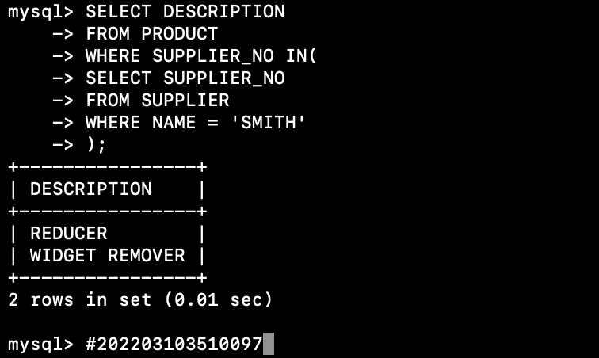
2) List all product no which are not ordered by the customer having same CORDER_NO as the CUSTOMER_NO 20.
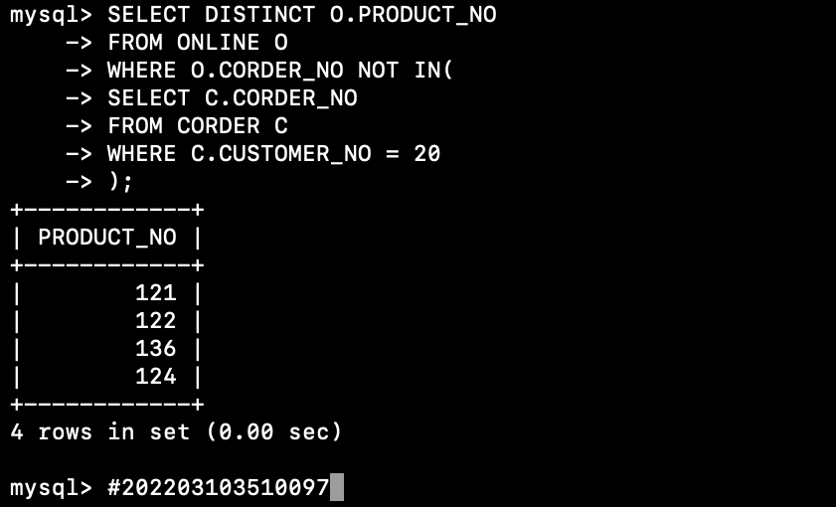
3) List the locations and addresses of all depots which stock any product which is supplied to the depot whose location is wales.
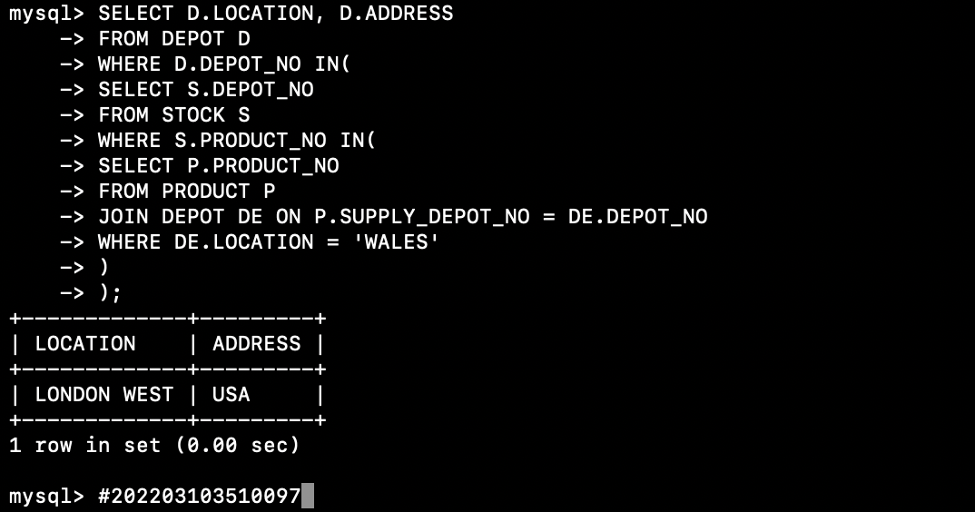
4) List the customer_no, date_placed and date_delivered for all orders which contain order lines for the product with product_no 137 using existential quantification (ie the where exists condition).
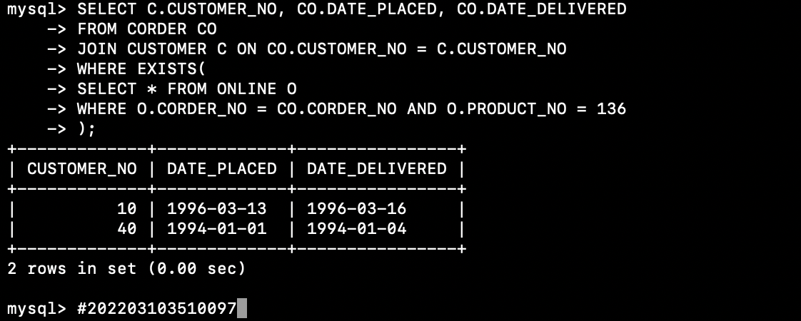

5) List the depots which do not stock any product supplied by the supplier whose name is ringworld.
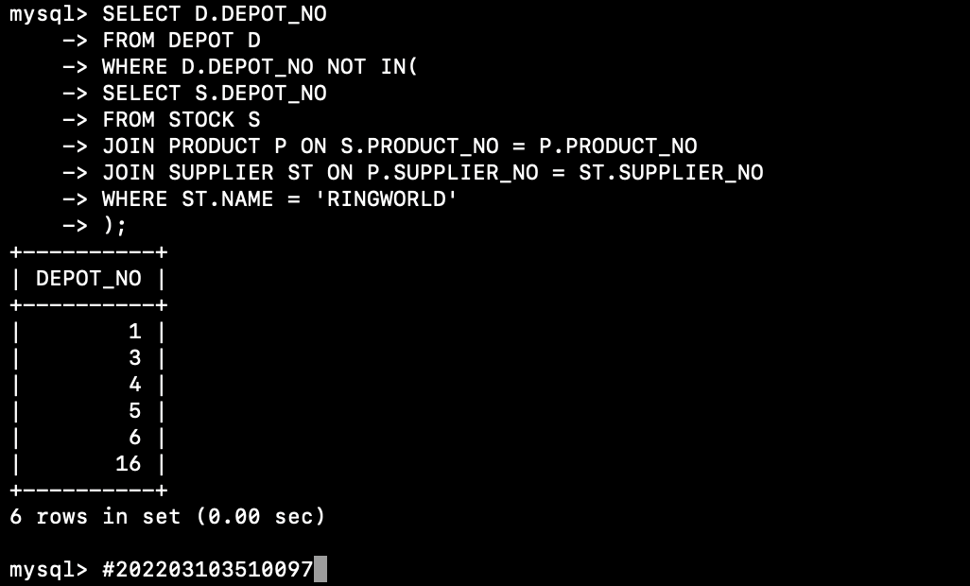
6)List the locations and addresses of all depots which stock all products supplied by the supplier babylon 5.
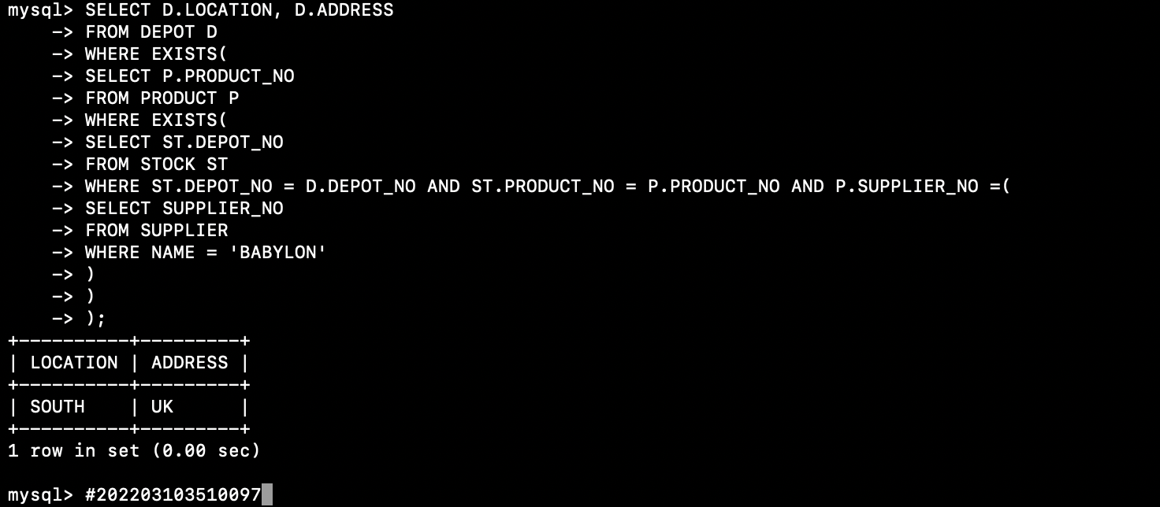

7) List the number of different products supplied by each supplier_no.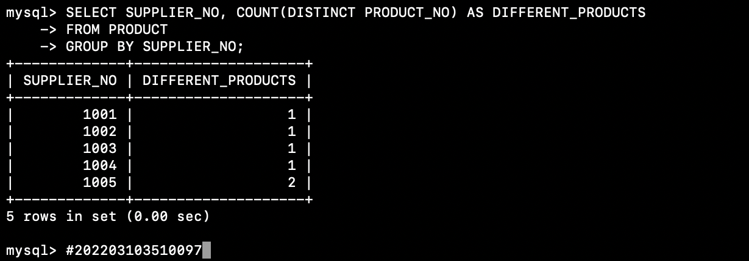

8) List the name of each supplier with the location of each depot and the number of products supplied by that supplier and stocked at that depot.
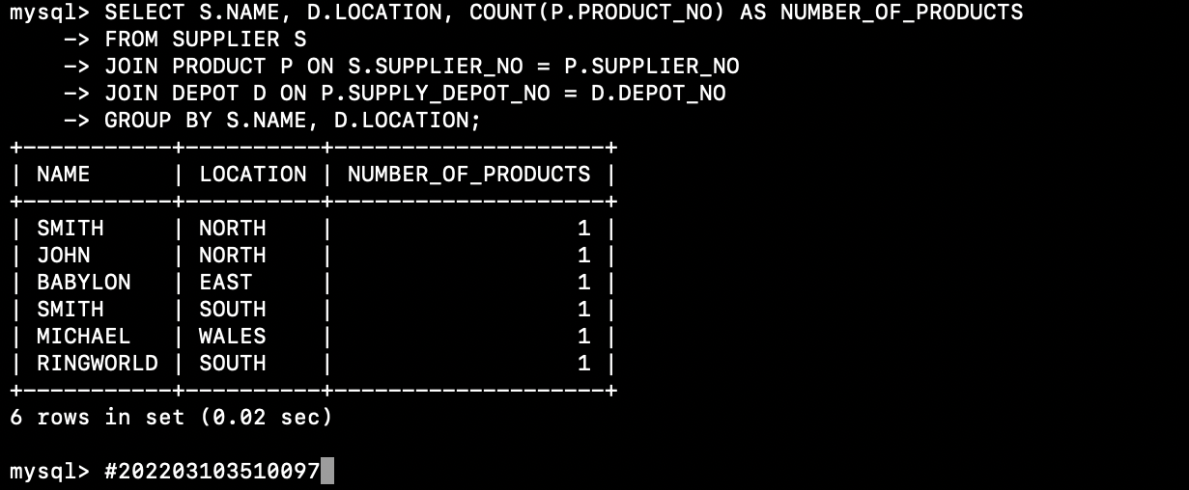

9) List all product descriptions with the product’s supplie name, sorted by product description within supplier name(i.e. all products for a supplier listed together in alphabetic order).
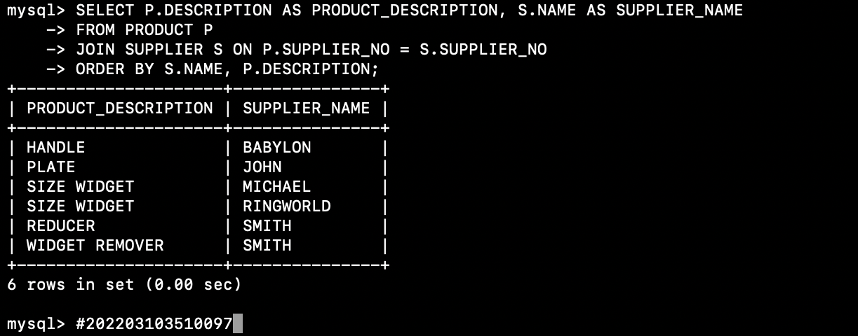

10) Display customer name who has ordered on same date.
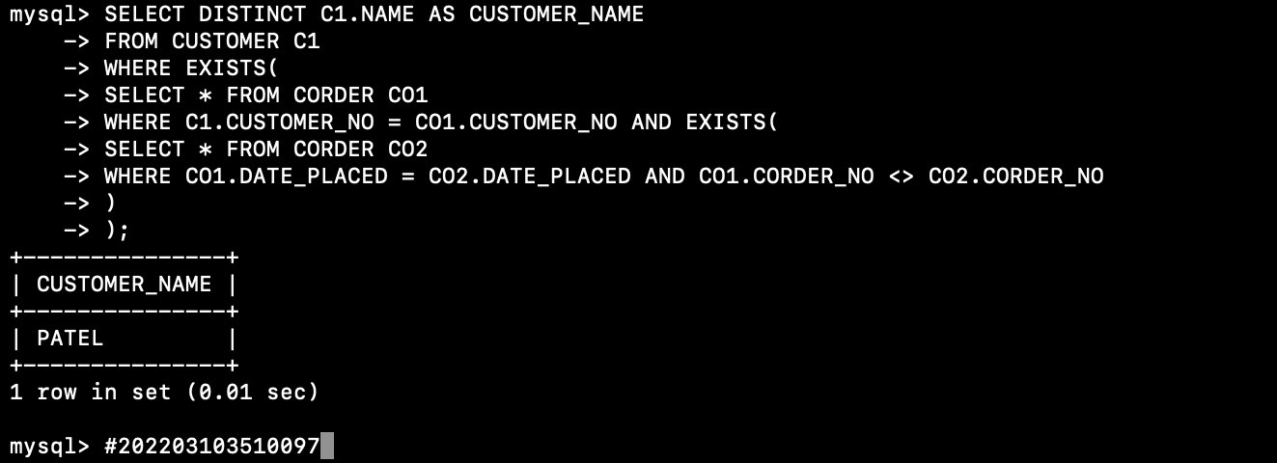

Conclusion: Implementing integrity constraints in queries, including subqueries, is a fundamental practice in database management. It ensures that data remains valid, consistent, and aligned with the defined rules and constraints, promoting data quality and the reliability of database operations.

